




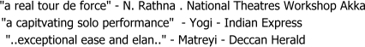



www.laxmic.com.
Saturday May 24th 2003 – 2:00 pm
$20 per family
$10 per individual at the door
Location: Hindu Temple of Wisconsin
For Information – 262-376-9576, 262-512-1190, 262-789-0231

